Sri Lanka Institute of Information Technology

**User Research**

**Project Name: Decent work and economic growth**

**User Experience Engineering**

**SE3050**

**Topic: spark**

**Group ID: SEJ006**

**Group Members**:

**IT20642914 – Gamage B.G.A.C (Data entry developer)**

**IT20641092 -Wijesinha W.S.S. (Job seeker)**

**IT20637064 – Anuththara R.M.C (Job consulter)**

**IT20639662 – Navodi P.T (Job poster)**

**Introduction**

The app that is tested for reducing unemployment for economic growth. The app is developed by job nest pvt and offer a lot of functionalities. Mainly the app allows to find a job for users and allows to post job advertisements for job provider. Furthermore, users can search jobs under job categories and they can view relevant jobs. Although it offers a lot of functionality from a user's perspective, there are a lot of shortcomings in the application itself when it comes to interface design and user experience in the following sections, we will discuss the usability testing process that was done in order to pinpoint those short comings, thus gathering the necessary information to improve the quality of the redesigned product.

**Test Objectives**

* Identify key features of the application that proposed
* Identify different user expectations and different view points
* Identify the technical knowledge of the of different user groups
* Identify the limitations of the users
* Identify the challenges that we have to face
* Identify the technologies that can be used to build the application
* Identify the resource limitations
* Identify the additional features that we should include according to the gathered requirements
* Identify fulfilment of all specified requirements

**Goals**

The goal of the Unemployment research is that ensure the requirements of as a receiver for this application. we took the self-employment, apply job opportunities, posting job vacancies, consult for the economic growth. those are the main goals and we need to clarify those requirements.

**IT20642914 – Gamage B.G.A.C**

The goal of the user research is that ensure the requirements of the date entry developer for this application.He wants to add job categories and add locations to the system. We gathered information via the google form from users. We ask about fields that they interested in to work. According to their answers we were able to get better idea about categorization of job opportunities according to the different fields. As well as data entry developer can update job categories and locations according to the job provider’s requests.

**IT20641092 -Wijesinha W.S.S.**

The goal of the user research is that ensure the requirements of the job seeker for this application. He wants to find a job that matches with his skills and his expected salary. As well as he wants to apply for a suitable job types. We gathered information about their salary range and what they willing to do for increase their income. Such as full time, part time, remote jobs and self-employment.According to the gathered information we noticed users wants to get notifications about similar job opportunities.

**IT20637064 – Anuththara R.M.C**

The goal of the user research is that ensure the requirements of the job consulter for this application.He wants to share about self-employment new job opportunities. He wants to consults to the peoples for getting start with self-employment and he wants consult for economic growth. For that we collect some suggestions from users via google form

**IT20639662 – Navodi P.T**

The goal of the user research is that ensure the requirements of the Job poster for this application. He wants to hire an employee that matches with skills as well as he wants to get notify after he posting job vacancy. Also he wants to get notify if employee applied for the job. We gathered new suggestions to improve the propose app

**Research Questions**

**IT20642914 – Gamage B.G.A.C**

* What are the expectations of the Data entry developer from this app?
* Did user have previous experiences
* Do all the features are required or not?
* Can they handle every feature in single application?
* Currently how do they manage the work?

**IT20641092 -Wijesinha W.S.S.**

* Identify different user categories as a job seeker
* Did user have previous experience with a similar app
* Did user face difficulties with that application?
* What are the suggestions for ease job applying process?
* What qualities that the user expect form the app when using?

**IT20637064 – Anuththara R.M.C**

* Did user have any idea how can start a self-employment
* Did the user have previous experience in self-employment?
* Did user expect to consult from consulter for a self-employment
* What features is the app going to need?
* What are the opinion on meeting the consultant via the app?

**IT20639662 – Navodi P.T**

* Did user wish to prioritise the agent job vacancies.
* What are the suggestions to improve the proposed app
* Did user like to filter job categories when posting jobs
* How do users feel about a mobile application?
* What features the user expecting from this proposed app

**Methodology**

For the user study; we carried out questionaries and interviews with relevant people according to the personas and we were able to identify pain spots and test the hypothesis.

User interviews and comments obtained using a shared Google form were the approaches for user experience research that were selected. When compared to expensive methods like ethnographic field research or usability lab studies, which were either much more expensive or time-consuming, these techniques were economical, accessible, and efficient.

**Interviewing**

* The objective was mainly to get an understanding about users that we target to use the application and identify the issues
* In order to do that a script was prepared covering all aspects of the functionalities that we are expecting to include in our system.
* Interviews were conducted online using the physically and moderated by team members by themselves

**Data Entry Developer** (**IT20642914)**

**--Questions to get an understanding of the user demography**

* First of all, tell us bit about yourself

* Have you worked as Data Entry Developer?

* can you describe your experience?

* did you faced any difficulties when you work as a data entry developer?

**--Questions to understand how the user thinks about the process as a Data Entry Developer**

* why are you interested in this role?

**--Questions to an understanding about how the user think about Data entry developer process using a app**

*Do you have any idea about job classification?

* As a Data entry developer, what are the qualities do you need for this application?

* What kind of process do you expect from our application?

* What method do you prefer to provide your service? For example, to serve via, hybrid or physical?

* Finally, do you have any suggestions for our app?

**Job Seeker** (**IT20641092)**

**--Welcome the user**

* Good afternoon Mr.Chandima I am Sachini from 3rd year 1st semester of faculty of computing of SLIIT and before I begin, I have some information for you.
* We are going to develop an application to find and applying jobs via online and we are testing the usability of this application and we are using these details only for our academic purpose.
* Here we are asking your thoughts and suggestions and we like to see how this application reacts when you are performing the tasks.
* So, Mr.Chandima, Are you OK with this, or else if you have any questions, you can ask

**--Questions to get an understanding of the user demography**

* So Mr.chandima,I would like to know a bit about yourself?
* What is the employment status of yours?
* What are the job fields that you interested in working?

**--Questions to understand how the user thinks about the process of finding and applying jobs via app**

* What are the methods that you used to find jobs?
* Do you have any experience in using online platform for finding jobs and applying for those jobs?
* How about that experience?
* What method do you prefer as the best for finding and applying jobs?
* Did you faced any difficulties when finding and applying a job via a app?
* what are the qualities you expect from a app for finding and applying jobs?
* Finally, do you have any suggestions for our application?

**--Thanks to the user**

**Job Consulter** (**IT20637064)**

**--Welcome the user**

**--Questions to get an understanding of the user demography**

* Hi Kavindu, can you please give me a brief introduction about yourself?

* So have you got any prior work experience as a consultant?

* ok great. How long have you been working as a consultant?

* How did you give consultancy? Via online sessions or did you had face to face Consultancies?

**--Questions to understand how the user thinks about the process as a job consulter**

* why are you interested in this role?

**--Questions to an understanding about how the user think about Job consulter process using a app**

* As a Job consulter, what are the qualities do you need for this application?

* What kind of process do you expect from our application?

* What method do you prefer to provide your service? For example, to serve via, hybrid or physical?

* Do you know what type of an app is this and what type of consultancy that you have to provide to the requested users?

* How to motivate self-employed?

* How do you work for economic growth via this application?

* Finally, do you have any suggestions for our app?

**--Thanks to the user**

Ok Mr.Kavindu Thank you for giving your valuable time and share your ideas with us. Have a nice day.

**Job Poster** (**IT20639662)**

**--Welcome the user**

* Good afternoon Ms.Oshini I am Tharushika from 3rd year 1st semester of faculty of computing of SLIIT and before I begin, I have some information for you.
* We are going to develop an application to find and applying jobs via online and we are testing the usability of this application and we are using these details only for our academic purpose.
* Here we are asking your thoughts and suggestions and we like to see how this application reacts when you are performing the tasks.
* So, Ms.Oshiji, Are you OK with this, or else if you have any questions, you can ask

**--Questions to get an understanding of the user demography**

* So Ms.Oshini,I would like to know a bit about yourself?
* What services or products do you offer?
* What qualities do you look for in new employees?

**--Questions to understand how the user thinks about the process of finding and applying jobs via app**

* How did you know about job next application?
* Do you have any experience in using online platform for post your job advertisement?
* As a job poster what are the experience you get from the application? (Good or bad)
* Did you wish to prioritize the agent job vacancies that you post?
* Did you want to have cv count for each job vacancies posted by you?
* Finally, I want to know,

what are the suggestions to improve the propose application?

**--Thanks to the user**

**Video Recording links:**

<https://mysliit-my.sharepoint.com/:f:/g/personal/it20642914_my_sliit_lk/EqCQm_5rELJAo98IE5VeEFgBysgZxkAPnkGyOPQ8abEH1Q?e=XCLNiK>

1. **Questionnaire**

Google Form Link : <https://docs.google.com/forms/d/e/1FAIpQLSdAZY1q_xIBcTzhaqGcI7OKX5RtH2OlGF2T8H2ITxbyZ59FPQ/viewform?usp=sf_link>

**Questions & Responses**

The questionnaire is divided into 4 sections

The first section contains questions to get a demography of the user

**Demographic questions**

* In order to get an understanding about the user’s demography questions such as
  + - Age group
    - Employment Status
    - Monthly income

**Section on Self-Employment**

* In this section mostly questions regarding the self-employment
* Also get advices from consultant how they can start or improve self-employment

**Section on Job Applying**

* In this section mostly questions regarding problems user faced when they applying for the job
* Also get suggestions to ease job apply process

**Section on Job Posting**

* In this section mostly questions regarding problems user faced when posting a job
* Also get suggestions to ease job posting process

**How the questionnaire should be distributed and data collection process?**

* The questionnaire will be distributed online since Google Forms was used to create it.
* WhatsApp groups will be used as the primary distribution channel.
* Online forums will also be used for data collection.

**Questions & Responses**

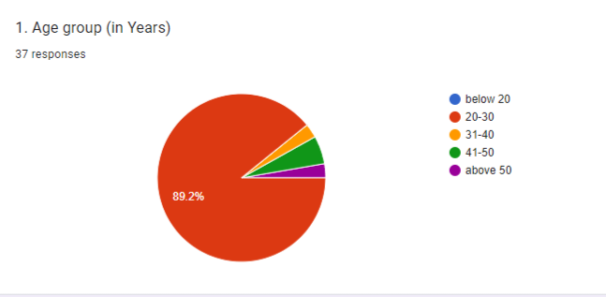

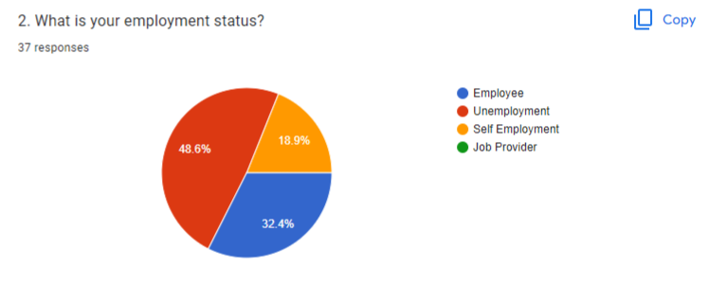

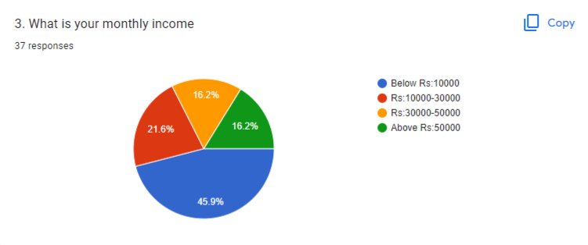

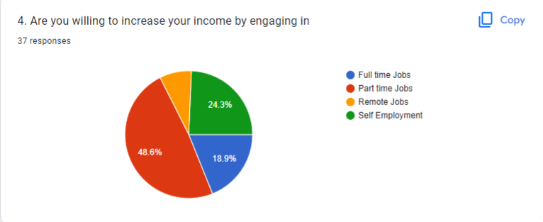

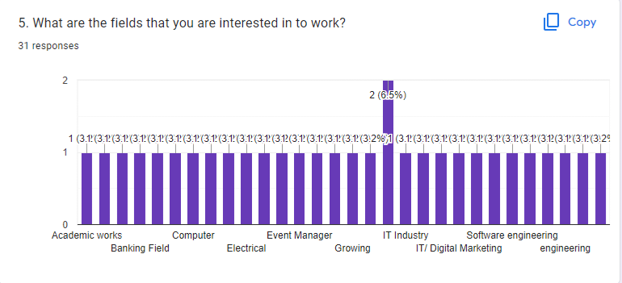

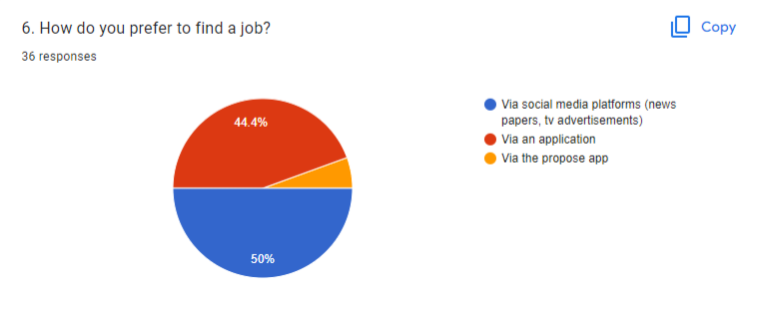

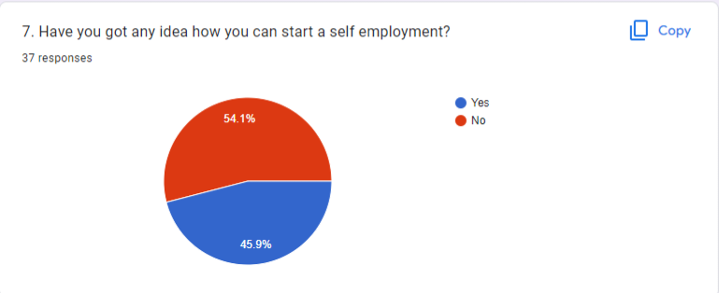

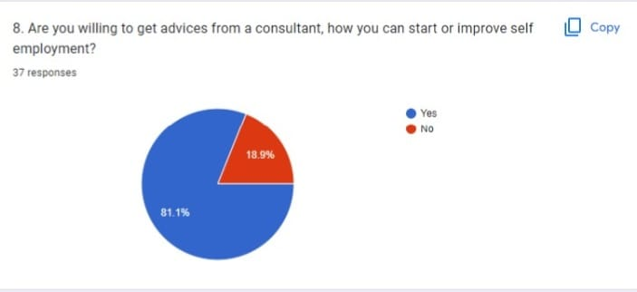

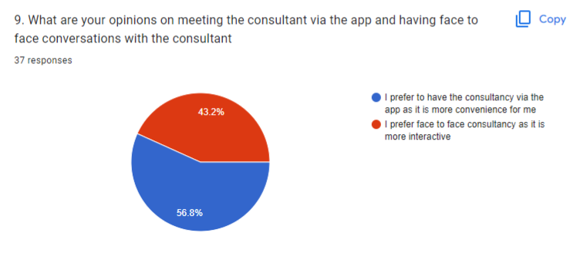

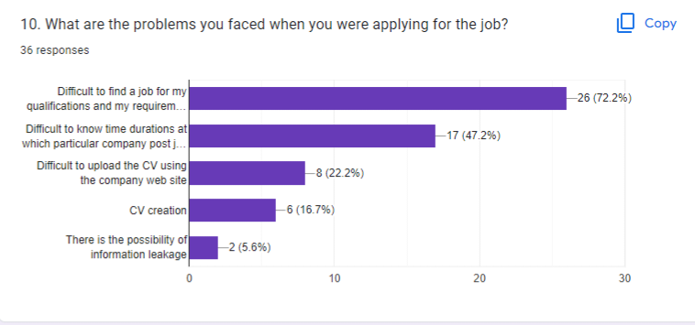

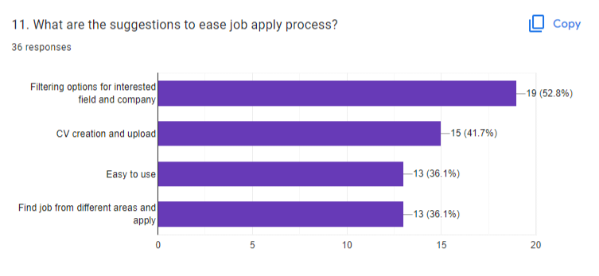

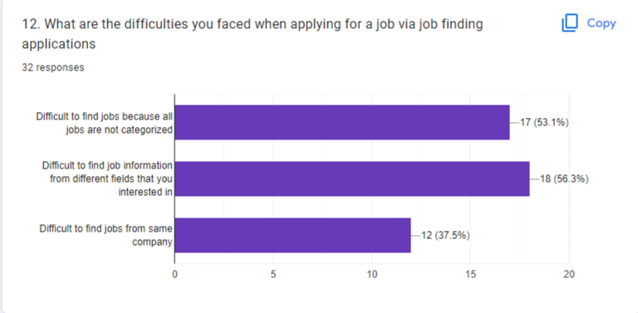

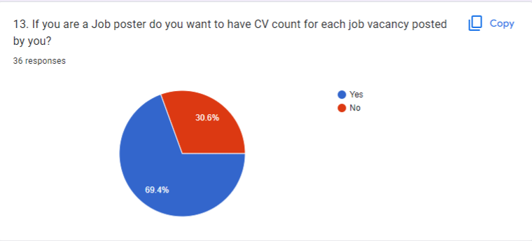

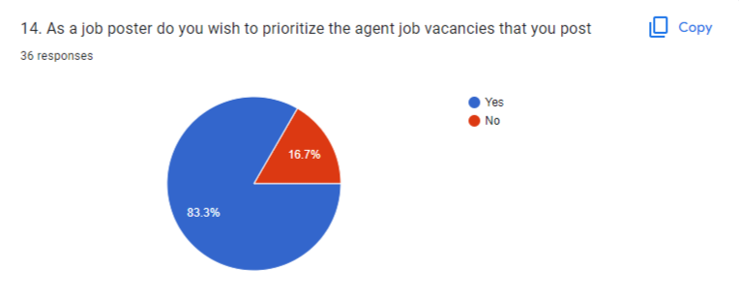

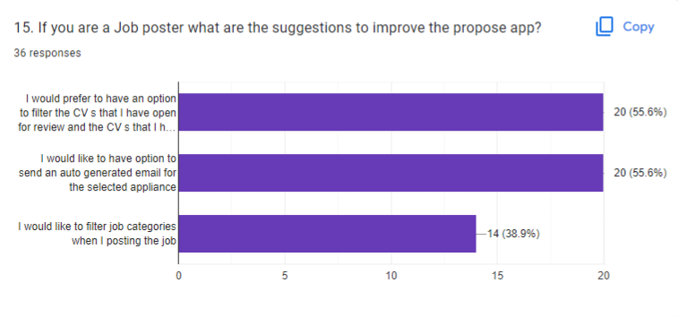

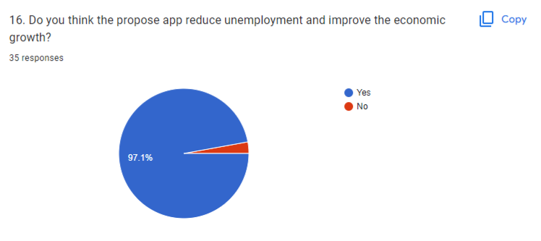

**Participants**

|  |  |  |  |
| --- | --- | --- | --- |
| **Interviewee Name** | **Demography** | **Location, Date and Time** | **Interviewer Name** |
| Ms.R.C.P Rajapaksha | Age: 26  Gender: Male  Marital Status: Single  Location: Colombo  Profession: Data Entry Developer | Location: Colombo  Date: 26/09/2022  Time: 4.00pm | **IT20642914 – Gamage B.G.A.C** |
| Mr.Chanadima sooriya arachchi | Age: 23  Gender: Male  Marital Status: Single  Location: Colombo  Profession: software developer (as a job seeker) | Location: Colombo  Date: 26/09/2022  Time: 2.00pm | **IT20641092 -Wijesinha W.S.S.** |
| Mr. Kavindu | Age: 28  Gender: Male  Marital Status: Single  Location: Colombo  Profession: Job Consultant | Location: Baththaramulla  Date: 26/09/2022  Time: 2.00pm | **IT20637064 – Anuththara R.M.C** |
| Ms.Oshini | Age: 25  Gender: Female  Marital Status: Single  Location: Colombo  Profession: Job provider | Location: Baththaramulla  Date: 26/09/2022  Time: 3.00pm | **IT20639662 – Navodi P.T** |

**Protocol**

The questionnaire is planned to be distributed online since it was created using google forms

● The main method that we used to share it through WhatsApp groups

● Also other social media platforms such as Facebook and Instagram are planned to be used

● One other method of data collection is online forums

We went to meet the Intervieweephysically.

Then we show the user flow and gave a brief introduction to our system.

Check Interviewee technical knowledge related to our app

Then get any suggestions from the Intervieweefor the app features.